Name | FREDERICK GEORGE DUNN  (Dusty)
Birth | Born in Hagg Bank Wylam 19/10/ 1894
Enlistment/Occupation | August 1914 Mechanic and aviator
Death, date, location | 26/05/1919  Died in crash of test flight of prototype Tarrant Tabor Bomber. Farnborough.  Entered France 03/10/1914 (Medal Rolls)
Age | 24
Unit, rank, service no: | RFC Roll No:1372.  Captain  Royal Flying Corps
Photograph from Royal Aero Club Aviators Licence Records 1914
Awards | Frederick George Dunn was awarded the Air Force Cross for Gallantry:-  NOVEMBER 7, 1918  It was announced in a Supplement to the London Gazette on November 2nd that the King has been graciously pleased to confer the Air Force Cross, and the Air Force Medal, respectively, on the under mentioned officers and  other ranks of the Royal Air Force, in recognition of valuable flying services performed in their various capacities—Flying Instructors, Test, Ferry, and  experimental Pilots, &c, &c.;—  Awarded the Air Force Cross  Capt. FREDERICK GEORGE DUNN.
Photo of ‘Dusty’ Dunn in RFC uniform provided by family | 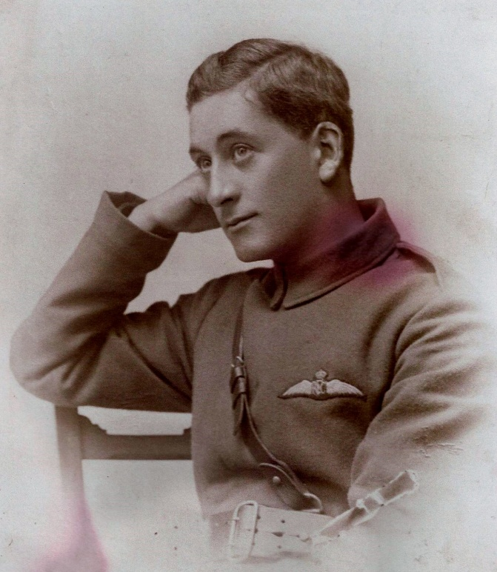
Family | The 1891 Census shows three Dunn brothers and one sister living in Wylam. They are David 25 and Thomas 28, both coal miners, living with their sister Margaret 24 at 5 Laburnum Terrace. The third brother Edward 31 also a coal miner was living with his wife Tamar at Elmfield Lodge. None of these three brothers or their sister originated in Wylam, but after periods in Ayreshire 1851, of Lancashire 1861 the family moved to Mickley Square by 1871 and then to Horsley Cottages just west of Wylam by the 1881 census. Father George died in 1875 aged 59 and mother Margaret in 1890 aged 66.  Three years after the 1891 census Thomas Dunn married a young French woman named Adele. The marriage registers for Hexham, Jan/Feb/March quarter 1894 show Thomas Dunn marrying Adele Virginee Rocheland aged 26. The marriage took place on 6th January 1894 at Ovingham. How Adele and Thomas Dunn met and eventually became man & wife remains unknown in detail. However, family sources indicate that Adele was employed as Lady’s Maid to Lady Parsons at Holeyn Hall, Wylam. It would seem that working as a Lady’s Maid was what brought Adele to the north country as there is additional evidence that she also worked for the Perkins family at Kirkley Hall as well during the relevant period.  The 1881 census had shown Adele, aged 19 working as a nursery maid for the family of a barrister living in Datchet, Bucks. It seems from her age given at marriage she must have been 16 when working in Datchet or maybe there have been transcription errors.  The 1901 Census shows Thomas Dunn now 38 living at Hagg Bank, Wylam with his wife Adele and his young son Frederick aged 6. Father Thomas, who originated from Manchester, is working as a coal miner/deputy at the pit while mother Adele, who is French, has taken British nationality.  The 1911 census shows that Thomas, his wife Adele, and son Frederick have now moved to a new address in London and a new occupation for Thomas. The family are living at 2 Queensbury Mews; East in South Kensington London where father Thomas is now employed as a chauffeur and Frederick aged 16 is an engineering student. Frederick is an only child.  Three years on from the 1911 census Thomas and Adele’s son Frederick, now aged 19, is recorded in the Royal Aero Club’s records as having achieved his Pilot’s Licence.  The list of pilots awarded an Aviators Certificate by the Royal Aero Club shows Frederick George Dunn has gained the aviators certificate flying a Bleriot Monoplane at the Bleriot School Hendon 23rd January 1914. Frederick’s occupation is given as a mechanic and there is a photograph attached to the records. The number on his pilot’s licence record is No: 728 which must place Frederick amongst the very first of those individuals who learnt to fly at the beginning of the 20th Century. At this time aeroplanes were only just being developed and flying was considered a high risk activity. In January 1914 Frederick would be just 19 years old which must make the gaining of his pilot’s licence at such a young age and from his social background in that period a very singular personal achievement.  Later that year Frederick Dunn joined the Royal Flying Corps at the outbreak of the war in August 1914 and went on to become a highly successful pilot and test pilot and popular figure on Tyneside as this article from the Newcastle Illustrated Chronicle for 14th April 1915 shows:-  Illustrated Chronicle (Newcastle)  Wednesday 14th April 1915 page 11  Wylam Aviator Promoted  Mr. F.G. Dunn son of Thomas Dunn of Wylam, one of the aviators who have played a prominent part in the operations at the front has been granted a commission for distinguished service.  Mr. Dunn is only 20 years of age and his rapid promotion will give great satisfaction to his friends on Tyneside.  An engineer to trade Lieut. Dunn became a draughtsman in Mr. Graham White’s school and went through a course of instruction at Hendon. He was subsequently made an instructor in aviation.  After war broke out he was for some time at the aerodrome at Gosforth and Newcastle people had many opportunities of witnessing his skills as a flier. From Gosforth he went to Farnborough and later flew across the Channel to France where his resource and bravery have won for him high distinction. He has for some time been one of the aerial fleet of scouts.  This must have been the newspaper article that inspired Mr. Ralph Brady, Headmaster at Wylam School to make the following entry into the School Log Book P.145 15/04/1915 where he paraphrases the article and adds a few additional facts about Frederick George Dunn one of his former pupils:-  Read newspaper report re: Lt. F.G. Dunn, Royal Flying Corps to assembled school. Lieut. Dunn was born in Wylam on 19th October 1894 and attended the old school from 1899 to 1905 when he moved to London. There he secured an apprenticeship with an engineering firm and subsequently became a draughtsman in Mr. Graham White’s School for Aviators and afterwards an instructor at Gosforth and Farnham. On the outbreak of the Great War he was sent to the Continent and although only 20 years of age he was engaged in various arial raids against the enemy. His resource and bravery won the admiration of his superiors and he was recently granted a Commission for his Distinguished Service. (Bravo Wylam)  A full obituary and record of his war time career both as a pilot on active service and as a test pilot written by Desmond Mountjoy is available on-line in Graces Guides. The following quotes are copied from that obituary:-  ‘Immediately war was declared Frederick George Dunn, or Dusty, as he came to be known in the Air Service, volunteered for work in the air, was accepted, and Thursday, August 13, 1914, found him flying a Bleriot machine at Gosforth Aerodrome and his picture in the illustrated papers, together with that of Graham-White and Robert Lorraine, as amongst the earliest few trained pilots who had volunteered and been accepted for immediate active service as Aerial Scouts.’  ‘Having just completed forty hours' flying in England, he was, some seven weeks after war was declared, posted to A Flight, No. 3 Squadron, 1st Wing in France, with the rank of Sergeant Pilot.’  ‘During the first week in April 1915 he returned to England, having been two hundred and ninety hours in the air since his first flight at Gosforth on August 13, and having flown some seventeen thousand five hundred miles on every available make of machine in every sort of condition and stage of repair.’  ‘About this time the Authorities in England began to realise the vital importance of work in the air, and the immense necessity there was to send out to France without delay large numbers of machines that had been carefully tried and thoroughly tested at home. Dusty, having by now become well known for his skill, his almost superhuman understanding of flying machinery, and his perfect readiness to go up in anything, new or old, captured or British, that could be induced to leave the ground, was kept hard at testing work in various parts of England for many months.’  ‘When the Armistice was signed the Royal Aircraft Establishment at Farnborough was engaged in building the ill-fated Tarrant Triplane for the purpose of bombing Berlin. This being considered no longer necessary, it was decided to alter its design, turn it into a gigantic machine which was to be used for civilian purposes, and, possibly, to be entered for the flight across the Atlantic.’  ‘The trial of the Tarrant Triplane took place in the early morning of Monday, May 26, 1919. The machine nose-dived before or immediately after leaving the ground. Captain P. Townley Rawlings, D.S.C., the splendid and intrepid pilot who had bombed the Goeben in Constantinople harbour, was killed instantly; Dusty was fatally injured, and died on Wednesday evening at six o'clock at Cambridge Hospital without having recovered consciousness.’  There is evidence of Frederick Dunn or ‘Dusty’ as he was known maintaining contact with his family in Wylam during the war from two references in the Hexham Courant:-  One article in the Hexham Courant 15/12/1917 records a flying visit to Wylam by Capt. F.G. Dunn nephew of Mssrs David & Ed Dunn two of Wylam’s respected tradesmen. He left London for France on Thursday.  Both of Frederick’s uncles David & Edward became well known shop keepers in the village in the period before and after WWI. Uncle Edward Dunn was a grocer at 18 Ingham Terrace. This address is the shop facing the war memorial in Wylam. Uncle David Dunn was a grocer and draper at Laburnum House, Wylam he died 15/03/1925.  A second article contained in the ‘Wylam Notes’ section of the Hexham Courant 12/01/1918 records the fact that Captain F. G. Dunn had been wounded, but there was no further detail.  Captain Dunn died tragically on 28/05/1919 from the injuries received two days earlier after the flying accident on 26/05/1919. His grave is in the Victoria Road cemetery Farnborough.  It would seem that his father Thomas and his mother Adele continued to live in the south of England until they died. The probate records show that father Thomas Dunn died in 1929 in Croydon, Surrey and mother Adele Virginie died in 1939 in Croydon, Surrey.
Memorials | K. 9.  FARNBOROUGH (VICTORIA ROAD) CEMETERY  Also commemorated on:-  School War memorial plaque in the Falcon Centre, Wylam  Commemorated on family grave with his grandparents at Ovingham Cemetery.
Photograph of Frederick ‘Dusty’ Dunn’s grave. | 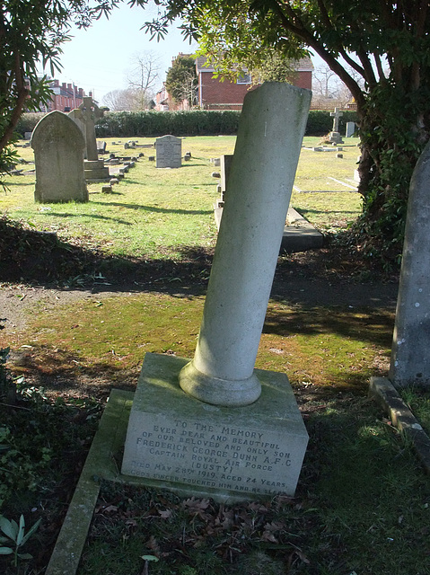  Victoria Road Cemetery, Farnborough, Hampshire.  Name: DUNN, FREDERICK GEORGE  Nationality: United Kingdom  Rank: Captain  Date of Death: 28/05/1919  Age: 24  Regiment/Service: Royal Air Force  Grave Reference: K. 9  Cemetery: FARNBOROUGH (VICTORIA ROAD) CEMETERY
Comments | Obituary in Graces Guides  Extract from The Melody of God and Other Papers by Desmond Mountjoy. Published 1922.  Chapter IV: Dusty. An English Flying Boy  Occasionally men are born who are so happy in their parentage and in all the surroundings of their lives that its every circumstance seems specially adapted to fit them for their destiny: Dusty (Frederick George Dunn) was one of these.  The only son of a Northumbrian father and a French mother, he was from his cradle in love with the machinery of movement and the idea of speed or flight. Born at Wylam-on-Tyne in October 1894, he was but two months short of twenty when war broke out and found him - one of the very few civilians - completely equipped and ready for his life work.  This obituary was written by Wellesley William Desmond Mountjoy 1884-1952. Desmond Mountjoy was an author, historian, playwright who knew Frederick George Dunn. Desmond Mountjoy’s own obituary is available in the National Archives.
Sources | WWW. Gracesguide.co.uk/  Great Britain, Royal Aero Club, Aviators’ Licences  1881/1891/1901/ 1911 census  Commonwealth War Graves Commission  Hexham Courant 15/12/1917 & 12/01/1918  Illustrated Chronicle 14/04/1915 + photo

